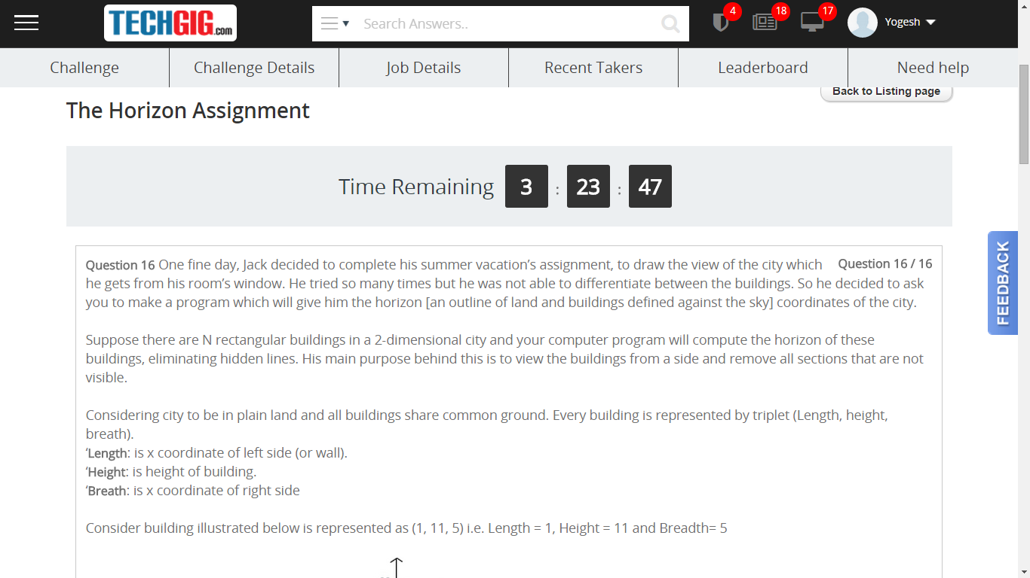

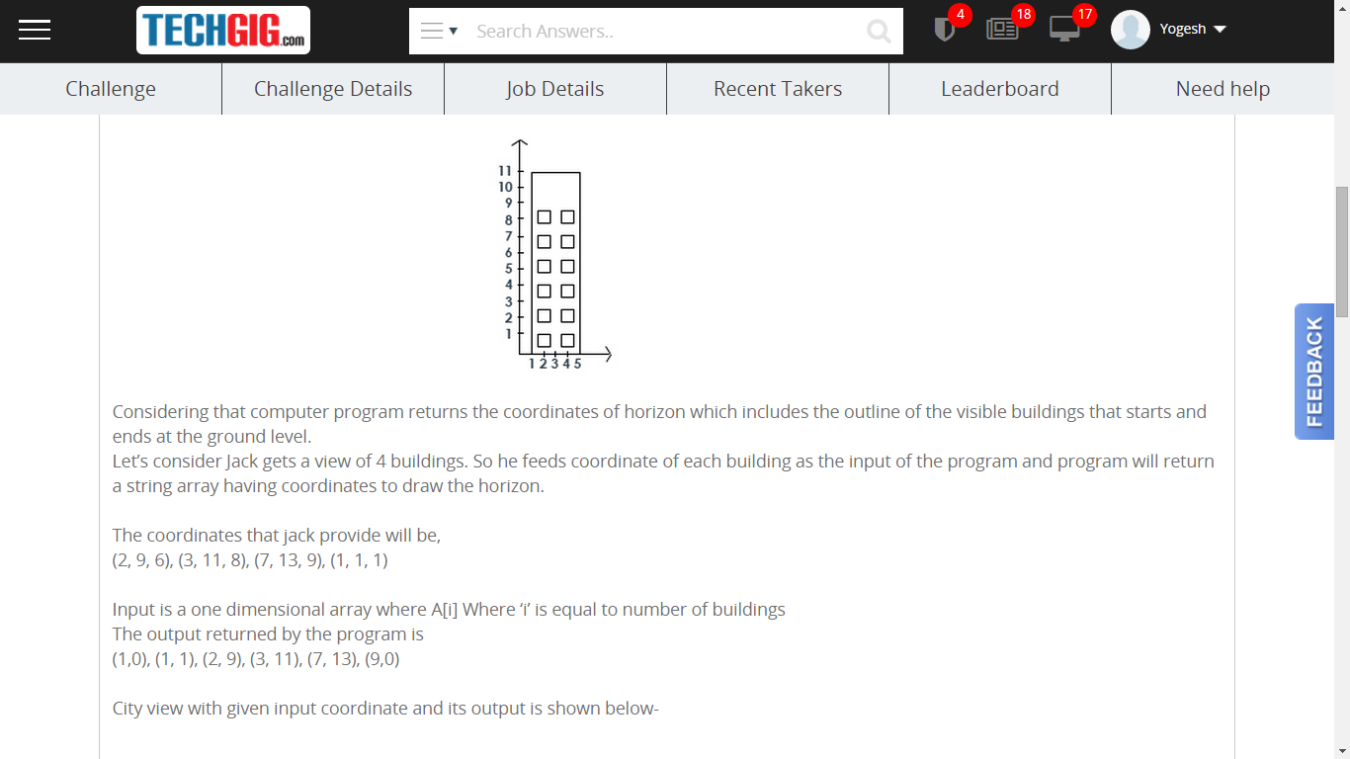

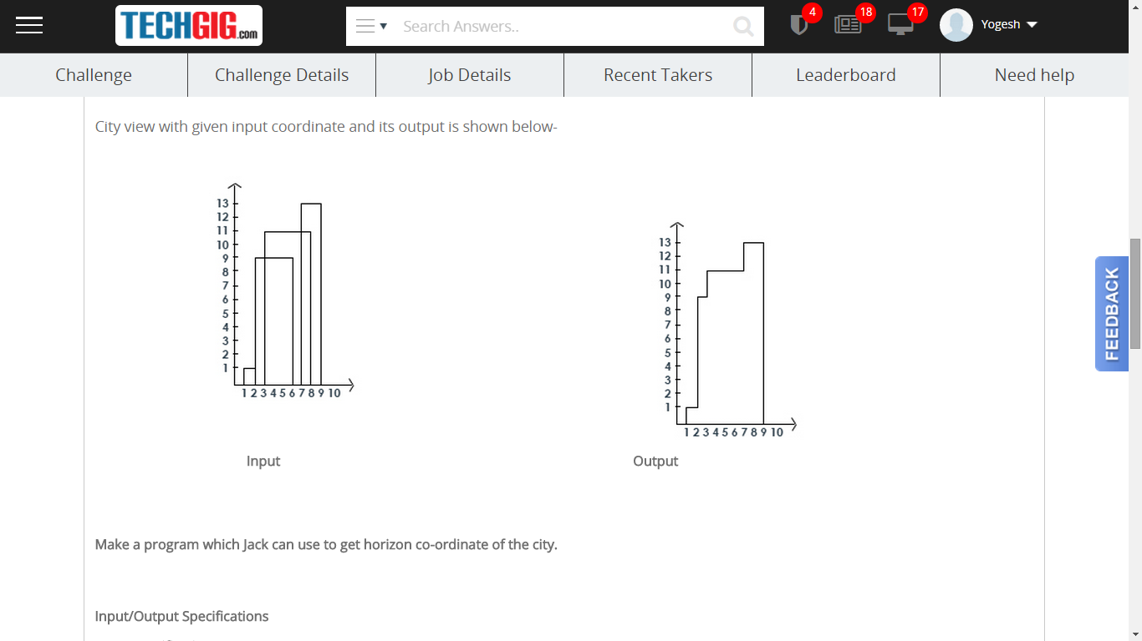

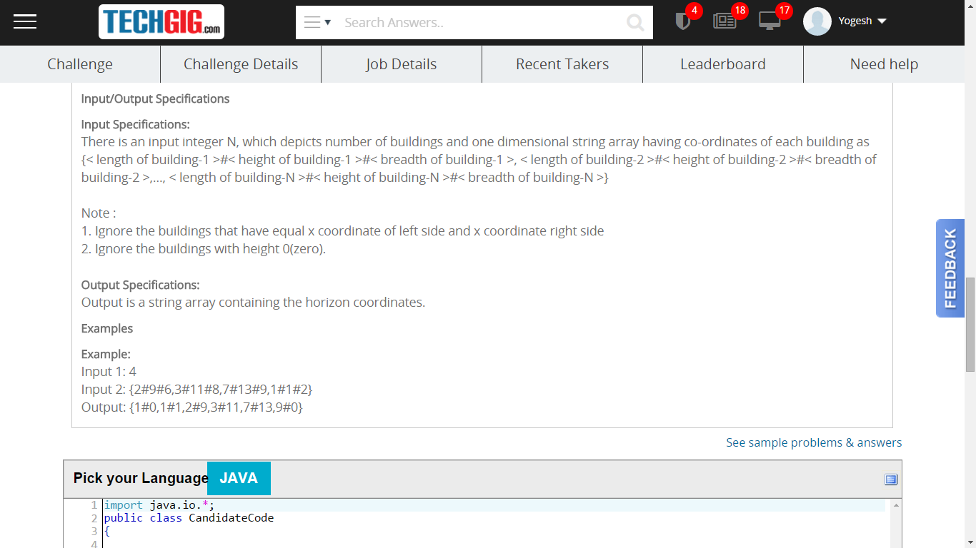

|  |
| --- |
| import java.io.*;  public class CandidateCode  {  public static String[] getHorizon(int input1,String[] input2)  {  //Write code here  }  } |